# Practical 8.2 - Formatted File I/O

On the I drive you will find a file "dunedin_events_2017.txt ". This file contains the result of a call to a dynamic JSON feed from the Eventful web service (api.eventful.com). Your task is to parse and use this JSON data in an Android app, as described below.

### Task 1: Figure out the JSON structure of the file.

If you simply open the file in a text editor, it is very difficult to determine the JSON structure, because, to minimise bandwidth, the Eventful feed uses no indentation or line feeds. To make this task easier, use a JSON viewer. I recommend [jsonviewer.stack.hu](http://jsonviewer.stack.hu/).

### Task 2: Fill a ListView from the JSON data.

You will see that the root JSON object has a key "events", whose value is an object. This object contains a key "event" whose value is an array. This array holds JSON objects. Each object in the array has a key "title", whose value is a string. Build an Android application that displays all the titles in a ListView.

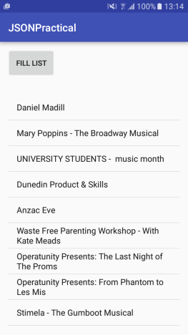

### Task 3: Add an OnItemClickListener to the ListView

Each object in the event array also has a key "description" whose value is a string (usually html). Add an item-click handler to your ListView such that, when the user clicks on an item in the list, the description string for that event is displayed via Toast. Think carefully about the programming logic and data management for this functionality. If you have managed your data correctly, you will not need to read the external file in again. Reading external files is very slow, so you should never do it unnecessarily. In the image below, I have clicked on the "University Students - music month" item.

